Part A — Practice Programs (Hour 1)
Work these in your lab-NN/ folder before the project: do the first one or two in the lab; the
last (For Advanced Learners) is for home.
1. Guarded calculator: read two numbers and an operator; throw a custom
DivideByZeroException and catch invalid-number input separately, printing a clear
message each time; loop until a valid calculation succeeds and use finally to log each
attempt.
import java.util.Scanner;

class DivideByZeroException extends Exception {
public DivideByZeroException(String message) {
super(message);
}
}

public class GuardedCal {
public static void main(String[] args) {
Scanner sc = new Scanner(System.in);
boolean validInput = false;

while (!validInput) {
try {
System.out.print("Enter first number: ");
int a = Integer.parseInt(sc.nextLine());

System.out.print("Enter second number: ");
int b = Integer.parseInt(sc.nextLine());

System.out.print("Enter operator (+, -, *, /): ");
String op = sc.nextLine();

double result;

if (op.equals("+")) {
result = a + b;
} else if (op.equals("-")) {
result = a - b;
} else if (op.equals("*")) {
result = a * b;
} else if (op.equals("/")) {
if (b == 0) {
throw new DivideByZeroException(
"Cannot divide by zero."
);
}
result = (double) a / b;
} else {
throw new IllegalArgumentException("Invalid operator.");
}

System.out.println("Result: " + result);
validInput = true;

} catch (NumberFormatException e) {
System.out.println("Invalid number. Enter integers only.");

} catch (DivideByZeroException e) {
System.out.println("Error: " + e.getMessage());

} catch (IllegalArgumentException e) {
System.out.println("Error: " + e.getMessage());

} finally {
System.out.println("Calculation attempt logged.");
System.out.println("--------------------------");
}
}
sc.close();
}
}
Output:
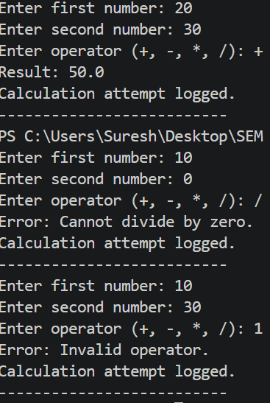

2. Stock issue: a Warehouse where issue(item, qty) throws a custom checked
OutOfStockException carrying the shortfall, and InvalidQuantityException for qty ≤ 0.
Process a list of requests, catching and reporting each failure without stopping the run.
import java.util.*;

class OutOfStockException extends Exception {
private int shortfall;

public OutOfStockException(int shortfall) {
super("Insufficient stock. Shortfall: " + shortfall);
this.shortfall = shortfall;
}

public int getShortfall() {
return shortfall;
}
}

class InvalidQuantityException extends Exception {
public InvalidQuantityException(String message) {
super(message);
}
}

class Warehouse {
private Map<String, Integer> stock = new HashMap<>();

public Warehouse() {
stock.put("Pen", 10);
stock.put("Book", 5);
stock.put("Pencil", 20);
}

public void issue(String item, int qty)
throws OutOfStockException, InvalidQuantityException {

if (qty <= 0) {
throw new InvalidQuantityException(
"Quantity must be greater than zero."
);
}

if (!stock.containsKey(item)) {
throw new OutOfStockException(qty);
}

int available = stock.get(item);

if (qty > available) {
throw new OutOfStockException(qty - available);
}

stock.put(item, available - qty);

System.out.println("Issued " + qty + " " + item + "(s) successfully.");
}
}

public class StockIssue {
public static void main(String[] args) {
Warehouse warehouse = new Warehouse();

String[] items = {"Pen", "Book", "Pencil", "Pen", "Book"};
int[] quantities = {3, 8, 0, -2, 2};

for (int i = 0; i < items.length; i++) {
try {
warehouse.issue(items[i], quantities[i]);
} catch (OutOfStockException e) {
System.out.println(
"Failed: " + items[i] +
". Shortfall: " + e.getShortfall()
);
} catch (InvalidQuantityException e) {
System.out.println(
"Failed: " + items[i] +
". " + e.getMessage()
);
}

System.out.println("--------------------");
}

System.out.println("All stock requests processed.");
}
}

Output:
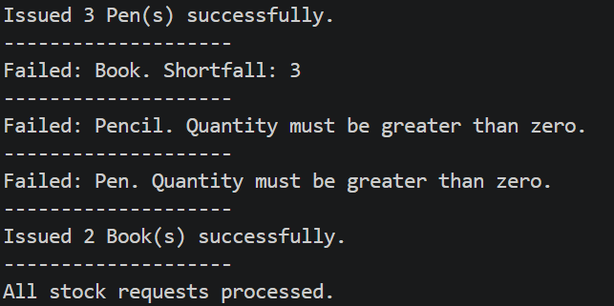

Key Questions / Analysis / Interpretation :
- What is the difference between a checked and an unchecked exception?
Checked exceptions are checked by the compiler and must be caught or declared using throws. Unchecked exceptions are subclasses of RuntimeException and do not have this requirement.
- What is the purpose of the finally block, and when does it run?
The finally block is used for cleanup operations. It normally executes whether an exception occurs or not, after the try and catch blocks.
- How does try-with-resources guarantee a resource is closed?
Try-with-resources automatically closes resources that implement AutoCloseable when the block finishes, even if an exception occurs.

